UCS553: Enterprise Web Application
Lab Experiment 1
Basic programming using JAVA
- Write Java Program to Check Leap Year
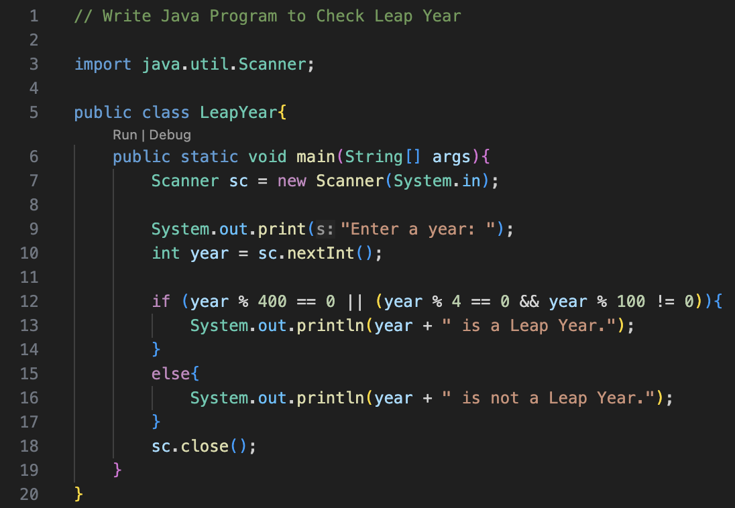
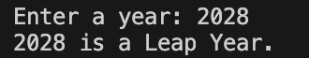
- Write Java Program to Check Whether a Character is Alphabet or Not
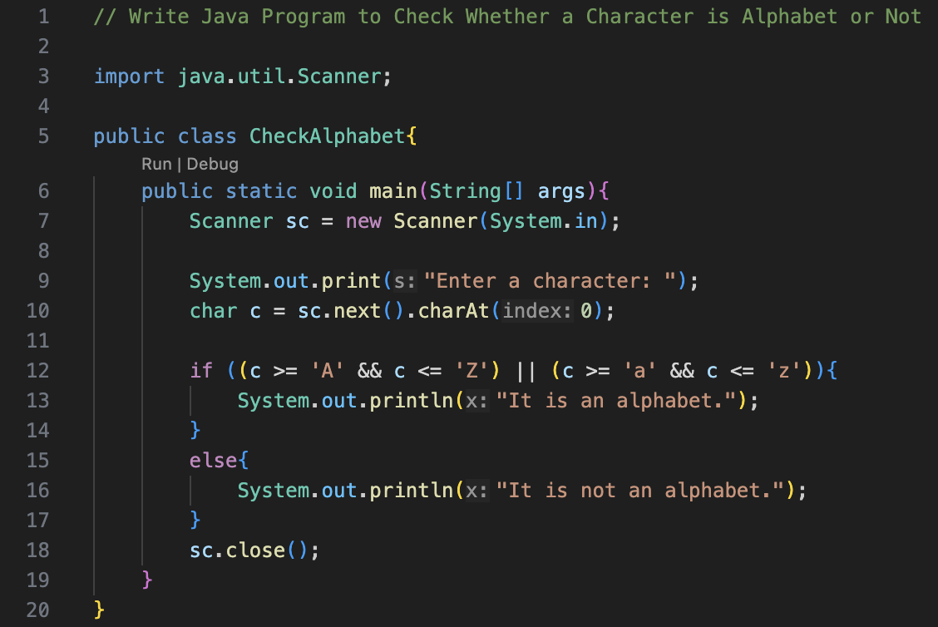
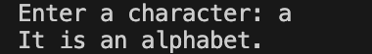

- Write Java Program to Find Factorial of a Number
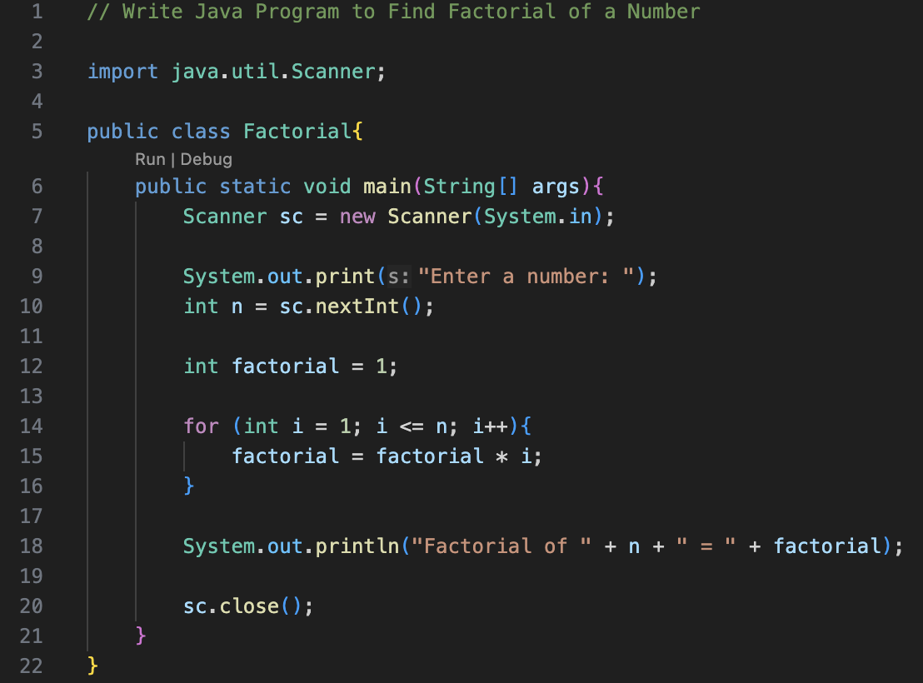
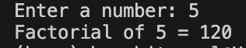
- Write Java Program to Display Fibonacci Series
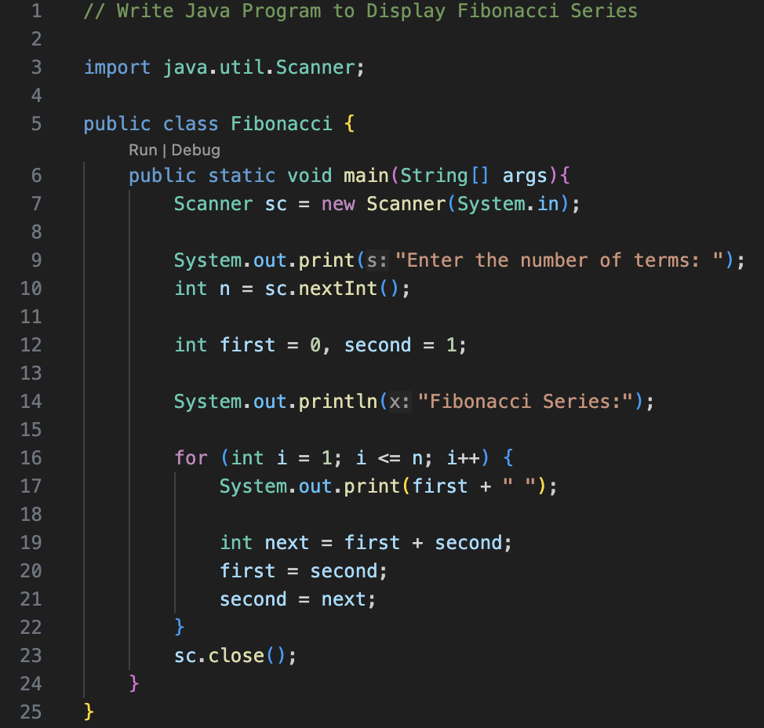
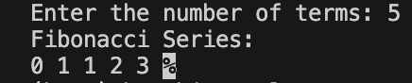

- Write Java Program to Find GCD of two Numbers
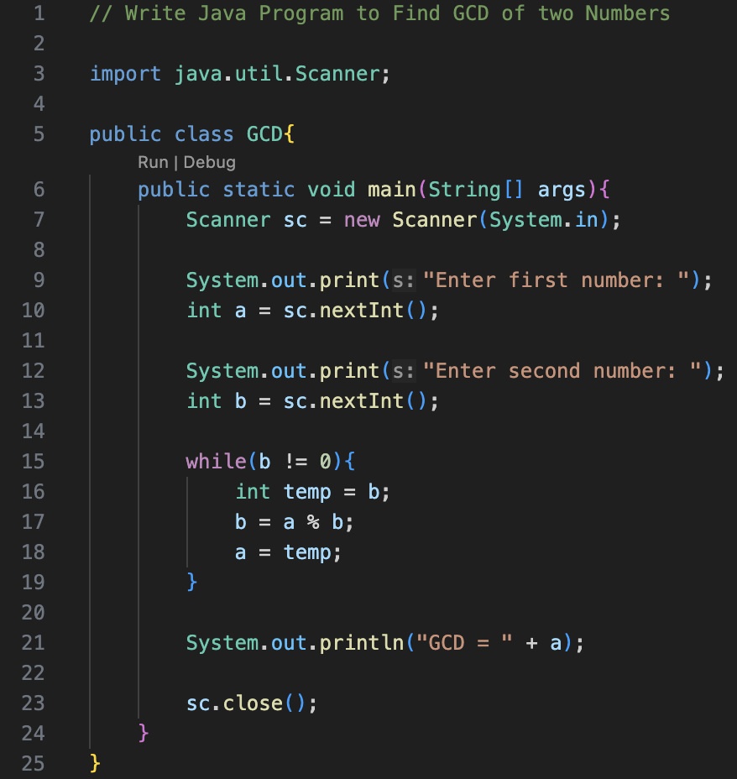
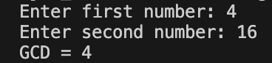
- Write Java Program to Find LCM of two Numbers
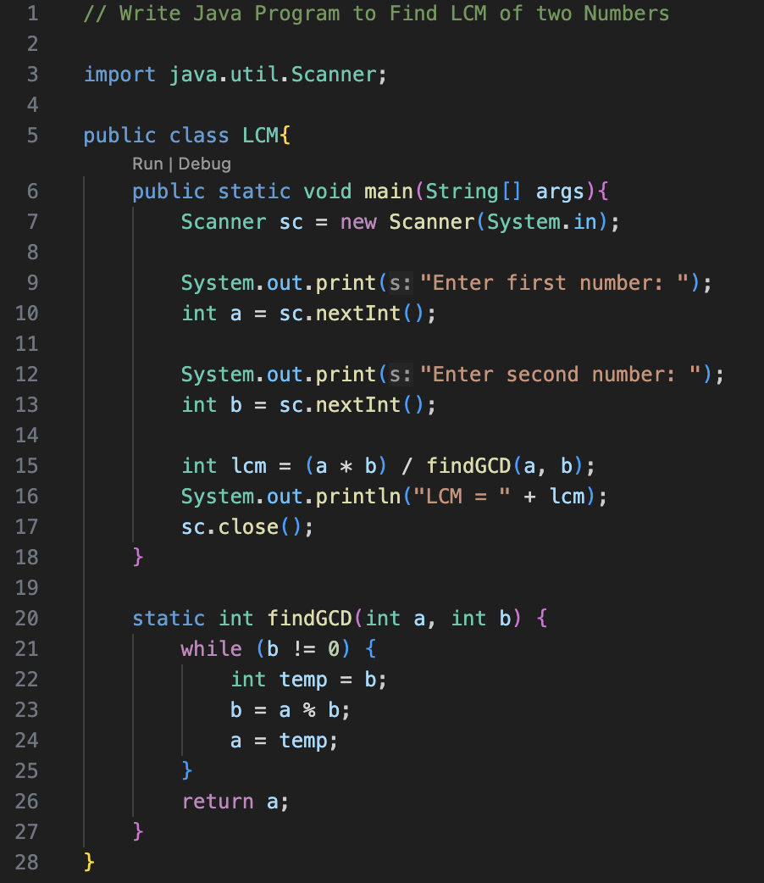
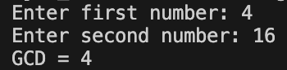

- Write Java Program to Count Number of Digits in an Integer
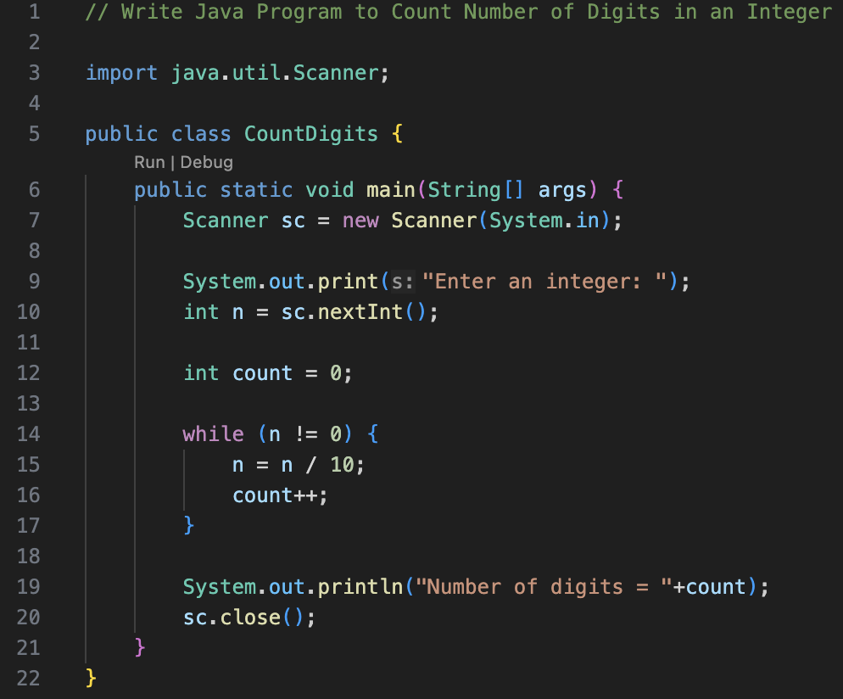
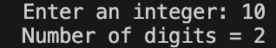
- Write Java Program to Reverse a Number
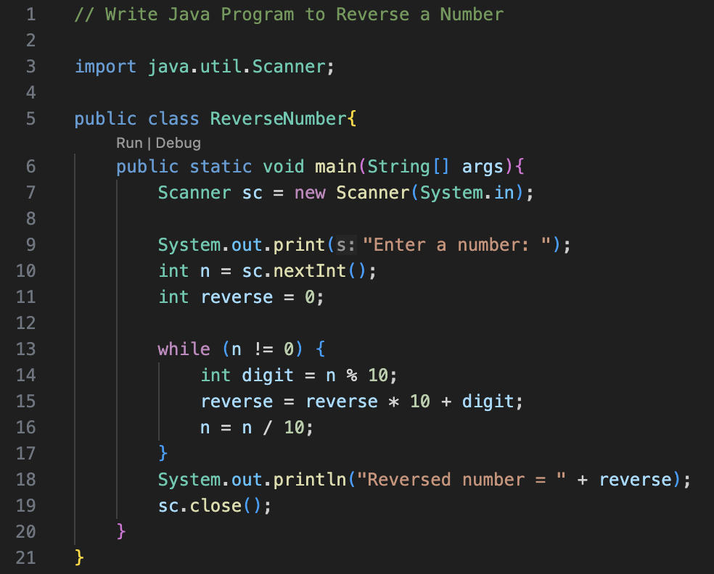
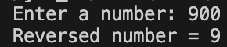

- Write Java Program to Calculate the Power of a Number
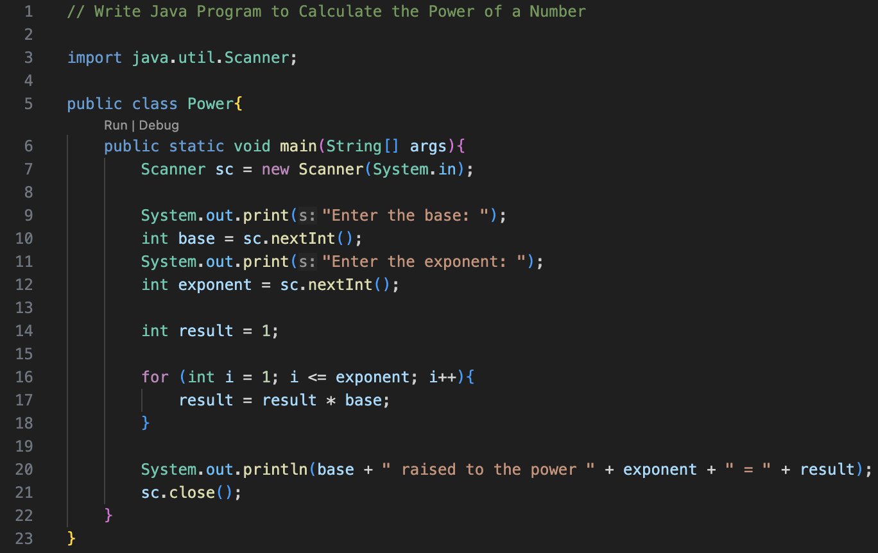
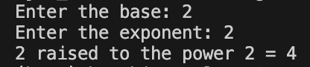
- Write Java Program to Check Palindrome
